**Pub pricing analysis**

**Introduction**

You are a Pricing Analyst working for a pub chain called 'Pubs "R" Us'

You have been tasked with analysing the drinks prices and sales to gain a greater insight into how the pubs in your chain are performing.

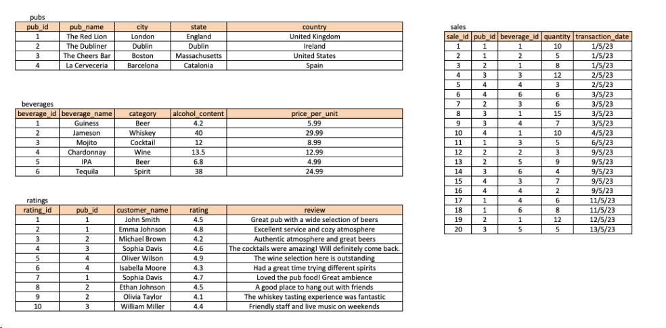

**Questions**

1. How many pubs are located in each country??

2. What is the total sales amount for each pub, including the beverage price and quantity sold?

3. Which pub has the highest average rating?

4. What are the top 5 beverages by sales quantity across all pubs?

5. How many sales transactions occurred on each date?

6. Find the name of someone that had cocktails and which pub they had it in.

7. What is the average price per unit for each category of beverages, excluding the category 'Spirit'?

8. Which pubs have a rating higher than the average rating of all pubs?

9. What is the running total of sales amount for each pub, ordered by the transaction date?

10. For each country, what is the average price per unit of beverages in each category, and what is the overall average price per unit of beverages across all categories?

11. For each pub, what is the percentage contribution of each category of beverages to the total sales amount, and what is the pub's overall sales amount?

**DDL & DML Statements**

CREATE TABLE pubs (

pub_id INT PRIMARY KEY,

pub_name VARCHAR(50),

city VARCHAR(50),

state VARCHAR(50),

country VARCHAR(50)

);

--------------------

-- Create the 'beverages' table

CREATE TABLE beverages (

beverage_id INT PRIMARY KEY,

beverage_name VARCHAR(50),

category VARCHAR(50),

alcohol_content FLOAT,

price_per_unit DECIMAL(8, 2)

);

--------------------

-- Create the 'sales' table

CREATE TABLE sales (

sale_id INT PRIMARY KEY,

pub_id INT,

beverage_id INT,

quantity INT,

transaction_date DATE,

FOREIGN KEY (pub_id) REFERENCES pubs(pub_id),

FOREIGN KEY (beverage_id) REFERENCES beverages(beverage_id)

);

--------------------

-- Create the 'ratings' table CREATE TABLE ratings ( rating_id INT PRIMARY KEY, pub_id INT, customer_name VARCHAR(50), rating FLOAT, review TEXT, FOREIGN KEY (pub_id) REFERENCES pubs(pub_id) );

--------------------

-- Insert sample data into the 'pubs' table

INSERT INTO pubs (pub_id, pub_name, city, state, country)

VALUES

(1, 'The Red Lion', 'London', 'England', 'United Kingdom'),

(2, 'The Dubliner', 'Dublin', 'Dublin', 'Ireland'),

(3, 'The Cheers Bar', 'Boston', 'Massachusetts', 'United States'),

(4, 'La Cerveceria', 'Barcelona', 'Catalonia', 'Spain');

--------------------

-- Insert sample data into the 'beverages' table

INSERT INTO beverages (beverage_id, beverage_name, category, alcohol_content, price_per_unit)

VALUES

(1, 'Guinness', 'Beer', 4.2, 5.99),

(2, 'Jameson', 'Whiskey', 40.0, 29.99),

(3, 'Mojito', 'Cocktail', 12.0, 8.99),

(4, 'Chardonnay', 'Wine', 13.5, 12.99),

(5, 'IPA', 'Beer', 6.8, 4.99),

(6, 'Tequila', 'Spirit', 38.0, 24.99);

--------------------

INSERT INTO sales (sale_id, pub_id, beverage_id, quantity, transaction_date)

VALUES

(1, 1, 1, 10, '2023-05-01'),

(2, 1, 2, 5, '2023-05-01'),

(3, 2, 1, 8, '2023-05-01'),

(4, 3, 3, 12, '2023-05-02'),

(5, 4, 4, 3, '2023-05-02'),

(6, 4, 6, 6, '2023-05-03'),

(7, 2, 3, 6, '2023-05-03'),

(8, 3, 1, 15, '2023-05-03'),

(9, 3, 4, 7, '2023-05-03'),

(10, 4, 1, 10, '2023-05-04'),

(11, 1, 3, 5, '2023-05-06'),

(12, 2, 2, 3, '2023-05-09'),

(13, 2, 5, 9, '2023-05-09'),

(14, 3, 6, 4, '2023-05-09'),

(15, 4, 3, 7, '2023-05-09'),

(16, 4, 4, 2, '2023-05-09'),

(17, 1, 4, 6, '2023-05-11'),

(18, 1, 6, 8, '2023-05-11'),

(19, 2, 1, 12, '2023-05-12'),

(20, 3, 5, 5, '2023-05-13');

--------------------

-- Insert sample data into the 'ratings' table

INSERT INTO ratings (rating_id, pub_id, customer_name, rating, review)

VALUES

(1, 1, 'John Smith', 4.5, 'Great pub with a wide selection of beers.'),

(2, 1, 'Emma Johnson', 4.8, 'Excellent service and cozy atmosphere.'),

(3, 2, 'Michael Brown', 4.2, 'Authentic atmosphere and great beers.'),

(4, 3, 'Sophia Davis', 4.6, 'The cocktails were amazing! Will definitely come back.'),

(5, 4, 'Oliver Wilson', 4.9, 'The wine selection here is outstanding.'),

(6, 4, 'Isabella Moore', 4.3, 'Had a great time trying different spirits.'),

(7, 1, 'Sophia Davis', 4.7, 'Loved the pub food! Great ambiance.'),

(8, 2, 'Ethan Johnson', 4.5, 'A good place to hang out with friends.'),

(9, 2, 'Olivia Taylor', 4.1, 'The whiskey tasting experience was fantastic.'),

(10, 3, 'William Miller', 4.4, 'Friendly staff and live music on weekends.');

--------------------